**DIGITEN – FL-308**

**DIGITEN G3/8" Quick Connect Water Flow Sensor Switch Flowmeter Counter 0.3-10L/min**

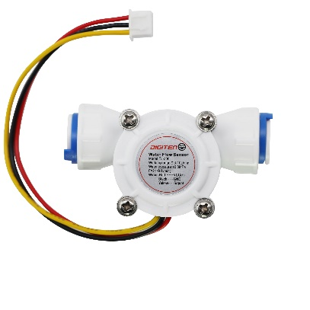

Waterproof, heat resistance, pressure resistance, cold resistance. Easy to install.

Frequency: F=21 * Q (L / Min) error: ± 2% voltage : 3-24VDC,

current can not exceed 10mA, 450 output pulses/liters,

F=constant * units of flow (L / min) * time (seconds)

Working range:0.3-10L/min

Working voltage range: DC 3-24 V

Operating Temp:≤80℃,Operating humidity:35%-90%RH

Pressure range: Water pressure 0.8 MPa below

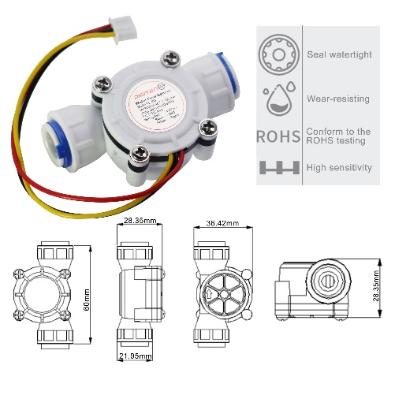Storage Temperature:-25-80℃

Storage humidity:25%-95%RH

Output Waveform: Square Wave, output pulse signal.

ROHS Compliant.

Cable length:15cm.

Wiring :Red---VCC(+)

Black---GND

Yellow----Signal